Biomolecules Background Information
Note Taking Summary Squares
First take a look at the nutrition label below.
What biomolecules do you see on the label?

Why do we eat?

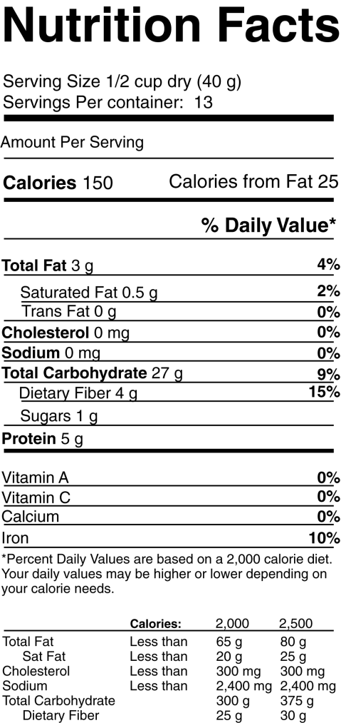
What are the 4 biomolecules?

There are four biomolecules or “life” molecules. They are carbohydrates, lipids, proteins, and nucleic acids. Biomolecules are organic molecules consisting primarily of carbon and hydrogen, oxygen, and nitrogen and, to a smaller extent, phosphorus and sulfur. Organic means carbon based. Each biomolecule serves specific functions in the cell and body. Most biomolecules are like a chain. Each “link” in the chain is called a monomer, and the chain itself is called the polymer. monomer
What are the 4 main elements in biomolecules?
Green plants produce carbohydrates through the process of photosynthesis. Carbohydrates are the body’s main source of quick energy because very little energy is required to break them down. There are three classes of carbohydrates: monosaccharides, disaccharides, and polysaccharides. Roots of words are important in science. “Saccharide” means sugar, “mono” means one, “di” means two, and "poly” means many. An example of a monosaccharide is glucose. An example of a disaccharide is lactose. An example of a polysaccharide is cellulose. Other polysaccharides are starches; plant starch is amylose, and animal starch is glycogen.
Why are carbohydrates the biomolecule that is used as quick energy or “fast fuel?”

*Below just recognize that each “ring” is a single sugar.
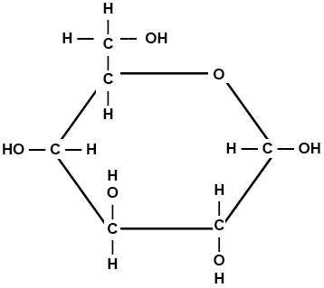
Monosaccharide Example: Glucose (C₆H₁₂O₆) – one ring
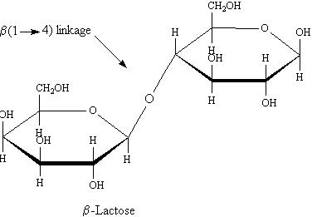
What is the monomer or “single chain link” of a carbohydrate?

Disaccharide Example: two rings
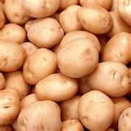
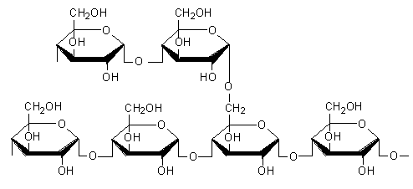
Polysaccharide Example: more than two rings
“Starches like pasta and potatoes are polysaccharides.”
Dietary fats, like those in butter, meat or cooking oils, are organic compounds. They consist of complex molecules and are the most highly concentrated source of energy in our daily diet. They belong to the class of biomolecules called lipids. While carbohydrates are used for quick energy, lipids store energy for future use. Unfortunately, dietary fats do not dissolve in water; as a result they are not easily broken down by fat-digesting enzymes in the watery content of the gastrointestinal tract. Thus fats tend to take longer to digest than carbohydrates or proteins. 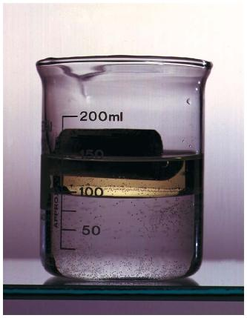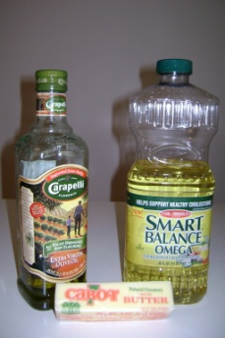
Why are lipids harder to break down than carbohydrates?

On a molecular level lipids are composed of one glycerol plus three fatty acids. They do not have monomers like the other biomolecules. See page 46 in the textbook.
What are the components of a lipid?

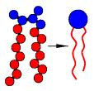
In addition to energy storage, the main function of lipids in the human body is to form cell membranes. The cell membrane is also called the phospholipid bilayer. The cell membrane regulates what goes in and out of the cell like a security guard in order to maintain homeostasis in the cell.
Individual phospholipid:

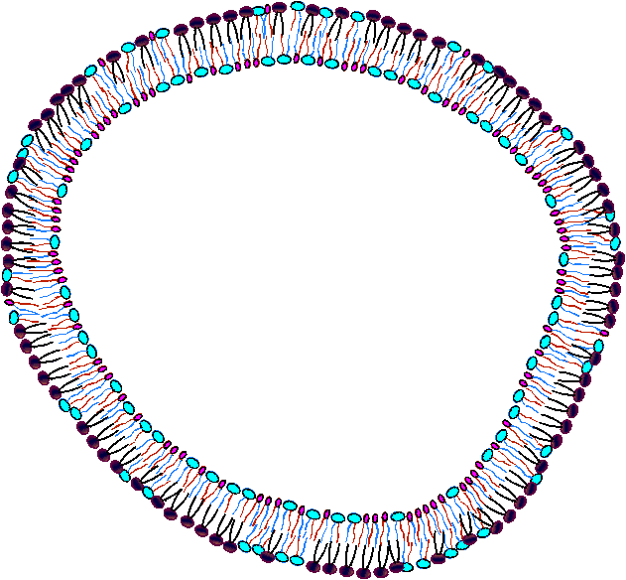
Here is a model of the cell membrane.
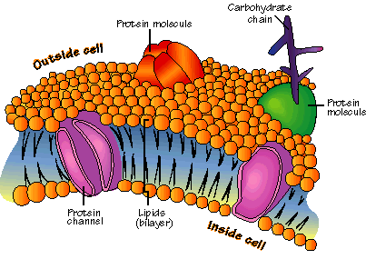

Proteins

Draw and label an individual phospholipid molecule.

Proteins are polymers of molecules called amino acids. In other words, proteins are a chain of amino acids. Proteins not only have carbon, hydrogen, and oxygen, but they also have nitrogen. Some proteins control the rate of chemical reactions or “metabolism” in the body. Some are used to form bones and muscles. Others are embedded throughout the phospholipid bilayer (cell membrane) in order to help transport substances into or out of cells.
What are 3 functions of proteins?

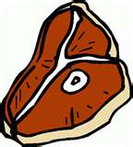
What is the monomer of a protein?

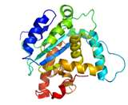
aa-aa-aa-aa-aa-aa
Protein
Circle a protein that helps transport things in and out of the cell in the diagram above.

Nucleic acids are polymers that are assembled from individual monomers known as nucleotides. Nucleotides consist of three parts: a 5-carbon sugar, a phosphate group, and a nitrogen base. Nucleic acids store and transmit hereditary, or genetic, information. There are two kinds of nucleic acids: ribonucleic acid (RNA) and deoxyribonucleic acid (DNA). RNA has the sugar ribose and DNA has the sugar deoxyribose. The entire purpose of DNA is the code to make proteins.
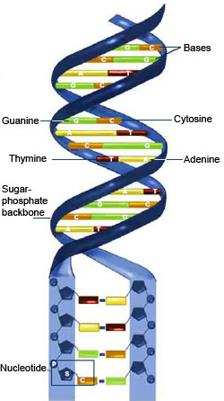
What is the function of a nucleic acid?

What is the monomer of a nucleic acid?
Draw and label a nucleotide.

DNA Molecule
What is the purpose of the above molecule?

In the Venn diagram below, COMAPRE and CONTRAST the two biomolecules:

