Name:_________________________________________ Date:_________________________________ Per:_________
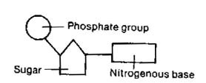
Test Review: Unit 4 DNA and the Cell Cycle: tinyurl.com/sphsbiounit4review
a.
b.
c.
- What is the monomer(smallest unit) of DNA?

- Label the three parts in the picture

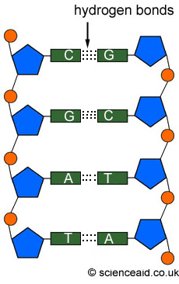
- Where is DNA found in eukaryotic cells? What is this DNA used for?
- What part of the DNA is responsible for the genetic code (a,b, or c?)
- What are the 4 bases found in DNA? Draw lines between the bases that pair together.
- Nitrogen bases are held together by ____________________ bonds. Label the bonds in the picture. Fill in the complementary strand of DNA
- If a sample of DNA is found to have 17% Adenine what are the percentages of the other 3 bases?
- Label the enzymes in each step of DNA replication and give a short description of what is happening in each step

- Why is DNA replication called semi-conservative?

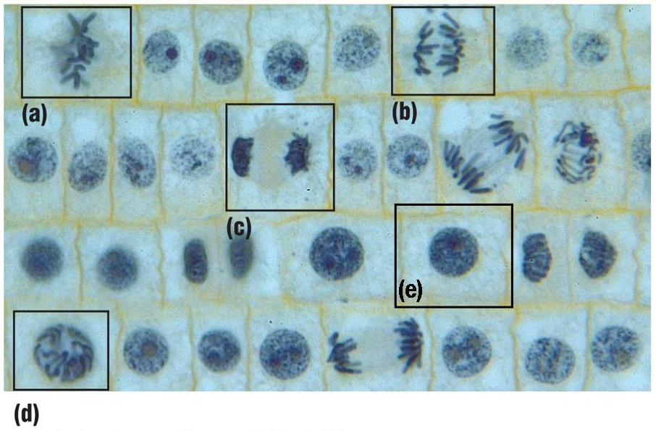
- Label the stages of mitosis

- Order the stages as they happen and give a brief description of what happens in each phase. (I Play Music At The Club)
- Label the different phases of the cell cycle (Label the Arrows with Interphase or M-Phase).
- How is cytokinesis different from mitosis?
- Cancer is caused by _____________ that disrupt the _______________
- Cancer cells are characterized by _____________ cell division
- Describe the difference between normal cells and cancer cells.

