**Name______________________Evolution Review Sheet**

1. Define the following terms

|  |  |
| --- | --- |
| Evolution | Common ancestor |
| Convergent evolution | Adaptive Radiation |
| Natural selection | Adaptation |
| Speciation | Temporal isolation |
| Gene flow | Genetic Drift |
| Genetic isolation | Behavioral isolation |

1. What are homologous structures?
2. What are analogous structures? Provide an example.
3. How do homologous structures provide evidence of evolution and relationships between organisms?

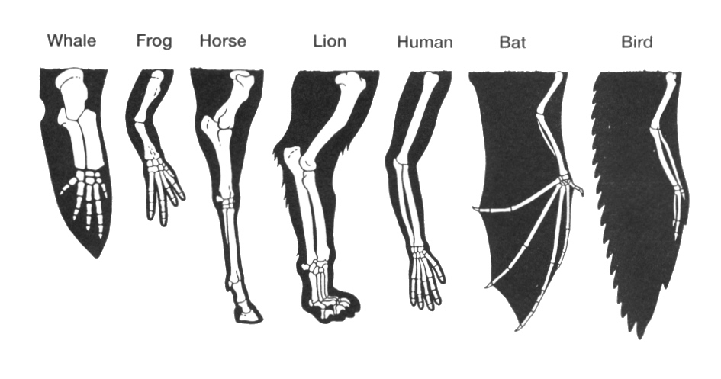

5.What are vestigial structures? Provide an example of a vestigial structure.

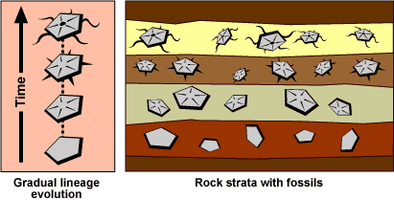

6.How can fossils of an extinct organism be found in two different continents?

7. What can you infer about the age of the fossils in the following diagram?

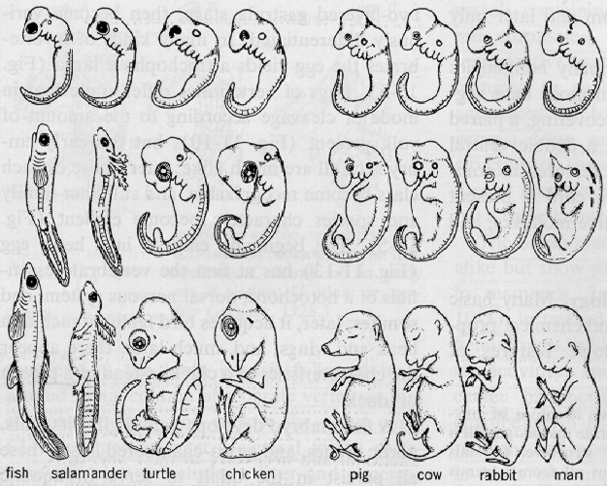8.How do similarities in the stages of embryonic development in different organisms show common ancestry?

|  |  |
| --- | --- |
| **Species** | **Sequence of Amino Acids in the Same Part of the Hemoglobin Molecules** |
| Human | Lys-Glu-His-Iso |
| Horse | Arg-Lys-His-Lys |
| Gorilla | Lys-Glu-His-Lys |
| Chimpanzee | Lys-Glu-His-Iso |
| Zebra | Arg-Lys-His-Arg |

9.How does the relationship of the amino acid sequence between organisms provide clues to common ancestry?

10.What type of evolution does each model represent?

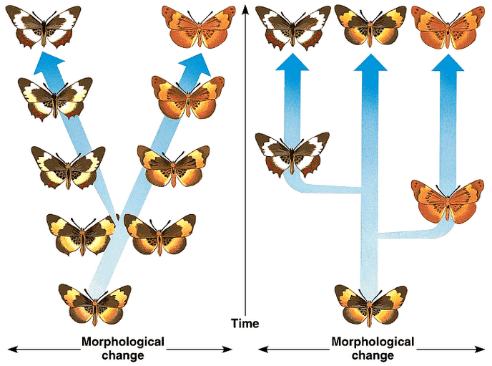

Model A Model B

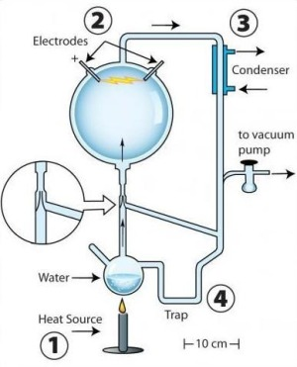12.What were the resulting compounds for the   
Miller-Urey experiment?

13.Students will be given scenario based questions to analyze the mechanism of evolution.

If you cut the tails off a population of mice and then breed them. What type of tails would the offspring have? Short or regular length tails?

A specific brand of termite poison claims to kill all termites in 2 applications. After the first application 85% of the termites were dead. Two months later the poison was reapplied but only 25% of the remaining population died. What has happened?

[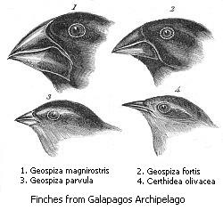](http://upload.wikimedia.org/wikipedia/commons/9/97/Darwin's_finches.jpeg)14. Why are these beaks different? Could all of these birds come from a common ancestor? What is your evidence?

[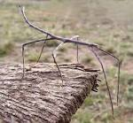](http://www.google.com/imgres?imgurl=http://naturescrusaders.files.wordpress.com/2008/10/walk-stick.jpg&imgrefurl=http://naturescrusaders.wordpress.com/tag/insects/&usg=__f8TsbghkhOAHhfoE7FMPKa6vYSc=&h=952&w=1024&sz=269&hl=en&start=12&zoom=1&itbs=1&tbnid=o__SxonT5-oeAM:&tbnh=139&tbnw=150&prev=/images?q=stick+bug&hl=en&safe=active&sa=X&rls=com.microsoft:*&tbs=isch:1&ei=WOU9TY_-K8SclgeDgeHpBg)

15. Give an example of gene flow. How is gene flow different from genetic drift?

16. How would the theory of evolution explain the insects that look like leaves or twigs?

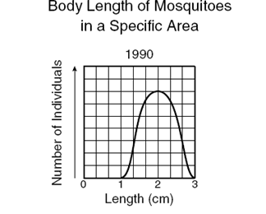

17. Given the following graphic, draw a graph that shows each of the three types of selection (stabilizing, directional and disruptive)

Stabilizing Directional Disruptive

18. How do geographic isolation and reproductive isolation contribute to the development of new species?

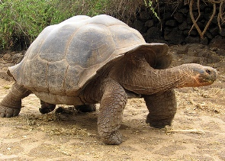

19. Why did the tortoises on different Galapagos islands become separate species?

20. What process explains why two different unrelated organisms such as the shark and the dolphin can closely resemble each other?

21. New alleles recently appeared in a population of deer; however, these alleles were not introduced into the existing population through mutation. Which mechanism is mostly likely responsible for this?