Name: Period:

Flower Dissection Data Sheet- Draw the parts as you dissect your flower.
Part A. Sepals and Petals
1. What functions might petals have?

Sepals Petals

Part B. Stamen and Pollen
2. How many stamens are present
in your flower? ___________
3. Therefore is your flower a monocot
or dicot? ___________.
How can you tell?

Stamen Pollen

4. How might pollen be carried from the anther to the female part of the flower?

Part C. Pistil and Ovary
5. How do you think the stigma is
adapted to trap the pollen grains and to
provide a place for them to grow?

6. Approximately how many ovules do
you see? _________________
(Note: Use dissecting scope to see
them clearly.) Pistil Ovary & Ovule

7. How close to the egg can the pollen grain get?

8. How do the sperm reach the egg?

9. The ovary develops into the __________________________.

10. The ovule develops into the __________________________.

LABEL THE PARTS OF THE FLOWER:

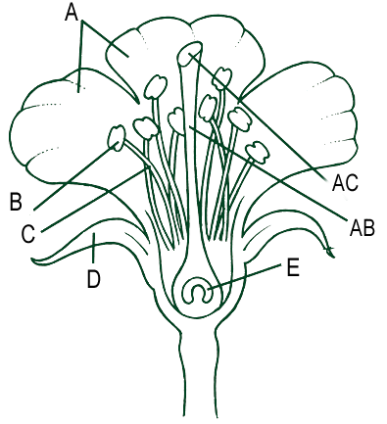
- ______________________

- ______________________

- ______________________

- ______________________

- ______________________

AB. _____________________

AC. _____________________

