**EVIDENCE OF EVOLUTION STATIONS**

**Adapted from TEA Homology Activity**

**EVIDENCE TYPE 1: FOSSIL EVIDENCE**

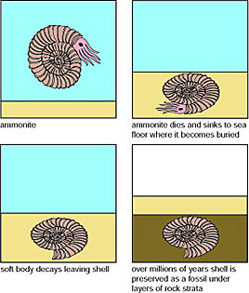**Fossil** – Remains/impression of a prehistoric organism preserved in/as a mold or cast in rock.

**Fossil Record -** Showsthe geological record of organisms on earth that have been preserved in the rock. The **Law of Superposition**- The oldest fossils will be in the bottom layer and newest fossils will be in the top layer.

Gradualism- The fossils may change gradually over time

Punctuated equilbrium- Long stable periods of stasis interrupted by rapid change.

**Figure: 1**

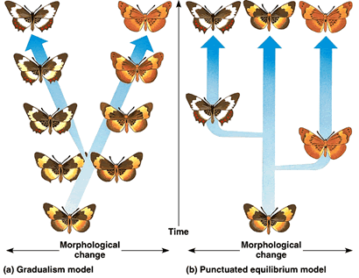

**CARD SORT: Place each sample in order from oldest on the bottom to newest fossils on the top, looking at how the population of this species has changed over time. HINT: Sample 2 is the oldest fossil**

**Dating the Fossil Record Card Sort**



**Station 1: Moleculary Homologies**

In biology, a **molecular homology** is defined as a similar nucleic acid (DNA) sequence shared among organisms that evolved from a common ancestor. Scientists look for molecular homolgies as a part of the evidence for evolution because organisms with similar genetic information will produce common amino acids and share common traits. With careful study, scientists can use molecular evidence to support or reject a hypothesis about the common origin of two organisms.

**EVIDENCE TYPE 2: BIOGEOGRAPHY**

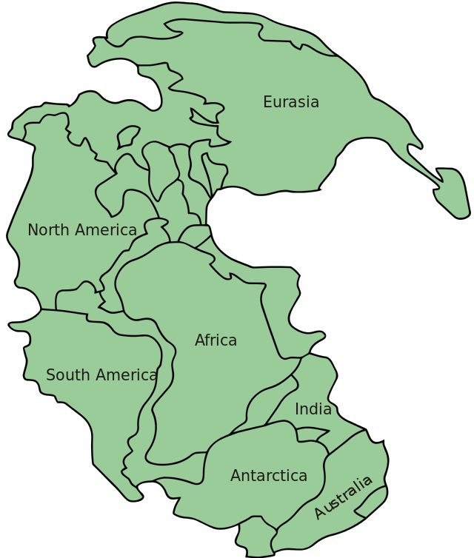**Biogeography – The geographic distribution of species**

**Pangaea – a supercontinent that was eventually separated by continential drift.**

**Figure 1.**

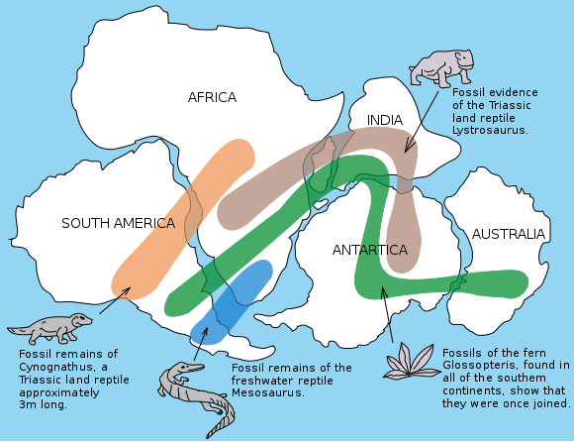

**Figure 2**

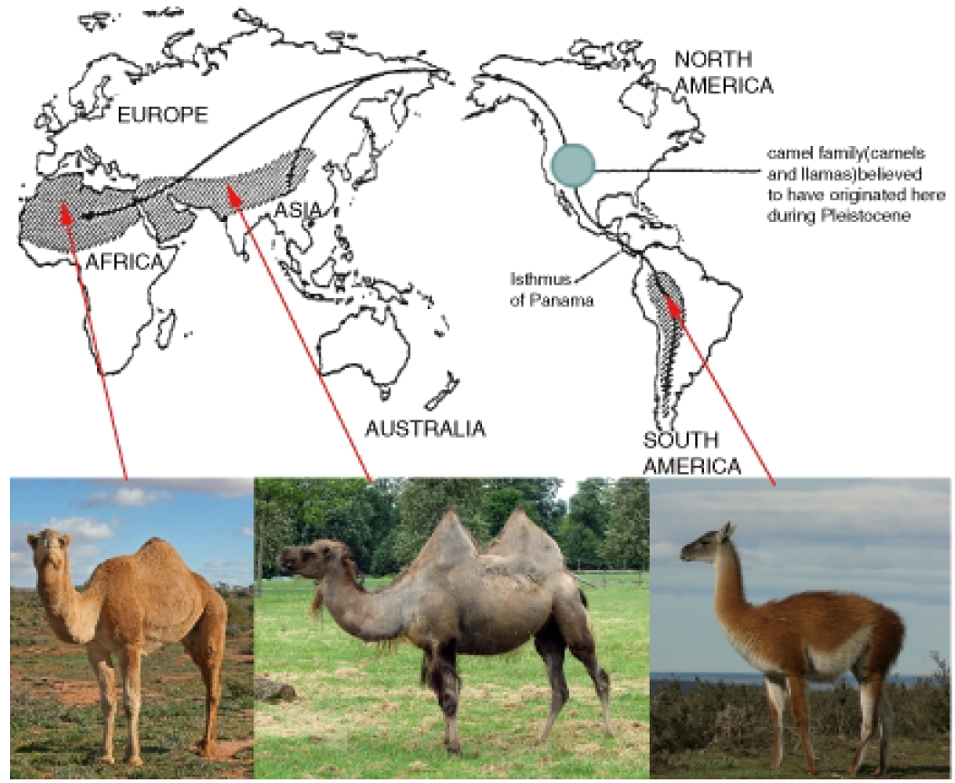

**Camel 1 Camel 2 Camel 3**

**BIOGEOGRAPHY CARD SORT**

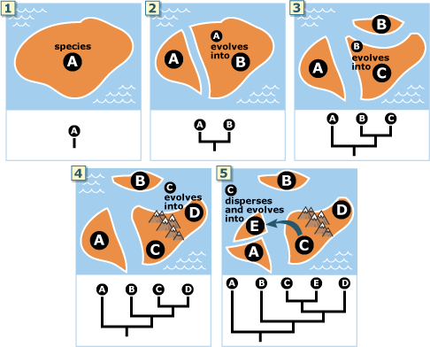

4

1

5

2

3

**EVIDENCE TYPE 3: MOLECULAR HOMOLOGIES**

**Remember!**

Homologies are similar features across species that suggest a common ancestor!

Organisms that share a common ancestor have will have similarities in their Molecular DNA, just like you and your cousin share DNA homologies because you have a common grandparent. Molecular homologies are similarities between organisms with common ancestors that share similar genetic information (DNA)

🡪Scientists have discoved a protein found in the cells of most eukaryotic organisms called **Cytochrome c**. Cytochrome C can help us determine how closely related species are to each other by comparing amino acid sequences. The more closely related two species are, the fewer the differences in the amino acid sequence. The more distantly related two species are, the larger the number of differences in the amino acid sequence.

**EVIDENCE TYPE 4: HOMOLOGOUS STRUCTURES**

**Remember!**

Homologies are similar features across species that suggest a common ancestor!

**Part A: Anatomical Homologies**

🡪In biology, **homologous structures** (anatomical homologies) are defined as a common structure such as bones and muscles found in two species. For example; a human arm and a lizard leg have similar muscular and bone structure. The functions of the structures may have changed over time. Scientists look for homologous structures as part of the **evidence for evolution**. With careful study, scientists can use homologous structures to support or reject a hypothesis about a common origin.

Homologous structures also indicate **divergent evolution**, which means two species have become more different through adapting to different environments.

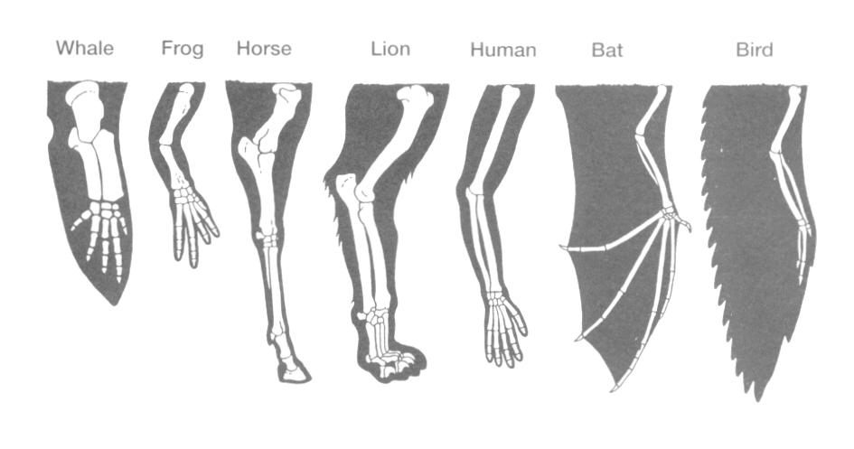

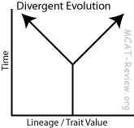

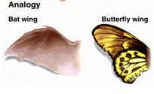**🡪Analogous structures** are two structures that have similar functions, but do not have the same anatomical structure. An example would be a bat wing and a butterfly wing. They’re both used for flight, but the wings are structured differently. Analogous structures indicate **convergent evolution** which iswhen two different species adapt in similar ways even when they’re not related.

1. Figure 1

**Whale fin**

**Human arm**

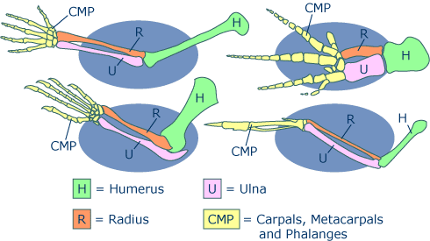

**Bird wing**

**Lizard leg**

Analagous vs. Homologous Structures

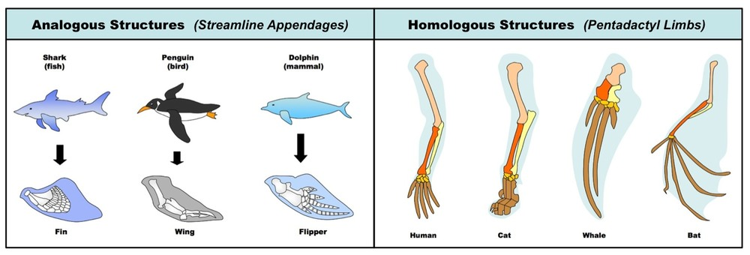

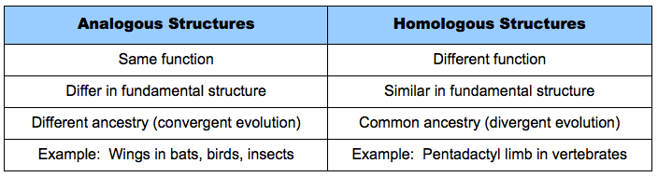

**CARD SORT 🡪 Use the cards provided to make two piles, one with analogous structure examples and the other with homologous structures. Use the chart above for reference.**

|  |  |
| --- | --- |
| **HOMOLOGOUS STRUCTURES** | **ANALAGOUS**  **STRUCTURES** |
| **Fin of a whale and leg of a horse** | http://www.zo.utexas.edu/courses/THOC/SharkDolphin.gif |
|  | **Grasshopper wing and bat wing** |
| **Wing of a bat and fingers of a human** | http://evolution.berkeley.edu/evolibrary/images/evo/bat_bird.gif |
| http://sunny.moorparkcollege.edu/~econnolly/MammalianII_files/image002.png | **The wings of sugar glider (a marsupial) and the wings of a flying squirrel (a placental)** |
| **Wing of a butterfly and wings of a grasshopper** | **Jumping legs of a kangaroo and jumping legs of a flea** |

**EVIDENCE TYPE 5: DEVELOPMENTAL HOMOLOGIES**

**Remember!**

Homologies are similar features across species that suggest a common ancestor!

**Part A – EMBRYONIC DEVELOPMENT**

In biology, a **developmental homology** is defined as similarities in the development of embryos (the starting formation of babies) between different species that share a common ancestor. Scientists look for developmental homologies as part of the **evidence for evolution**. With careful study, scientists can use developmental homologies to support or reject a hypothesis about a common origin

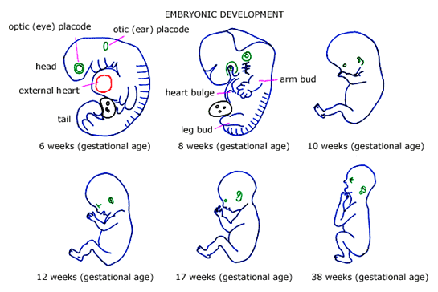

**EMBRYO CARD SORT**

**Sort the embryo cards at your table into the chart based on their physical characteristics. Your teacher will show you the key when you are done**

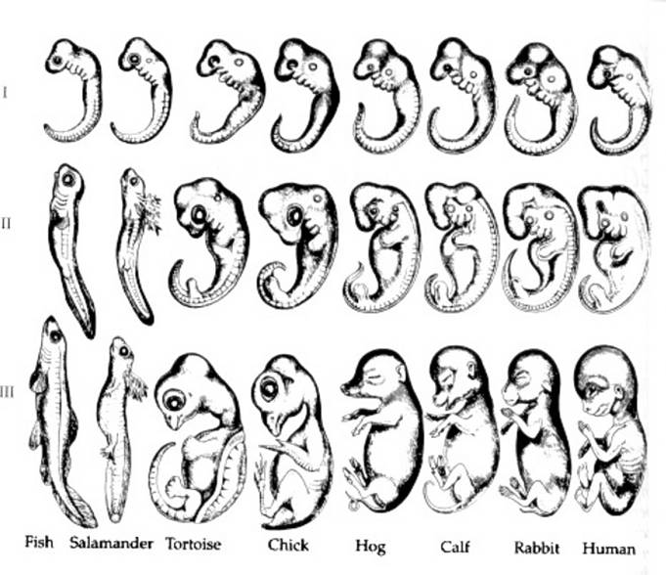

**6 weeks 8 weeks 10 weeks**

**EVIDENCE TYPE 6: VESTIGIAL STRUCTURES**

Gradual changes have occurred through time, which have in some cases reduced or removed the function of some body structures and organs. The human appendix, the penguin’s wings, leg bones of snakes are examples of this phenomenon. A **vestigial structure** is defined as a type of **homologous structure** that is no longer used in the way it once was by the organism’s ancestor. Vestigial structures can be analyzed by scientists to help determine the common origin between two organisms.

Analyze the diagram below and answer the questions on your paper.

**Figure 1: Cladogram of Whale Ancestry**

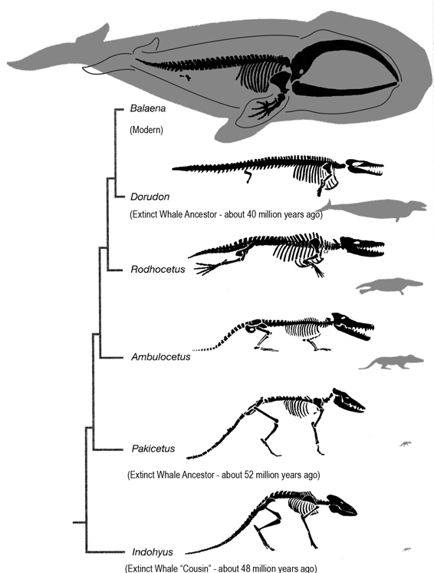

EVIDENCE TYPE 1: FOSSIL EVIDENCE

EVIDENCE TYPE 2: BIOGEOGRAPHY

EVIDENCE TYPE 3: MOLECULAR HOMOLOGIES

EVIDENCE TYPE 4: HOMOLOGOUS STRUCTURES

EVIDENCE TYPE 5: DEVELOPMENTAL HOMOLOGIES

EVIDENCE TYPE 6: VESTIGIAL STRUCTURES