Cell Membrane Model Lab
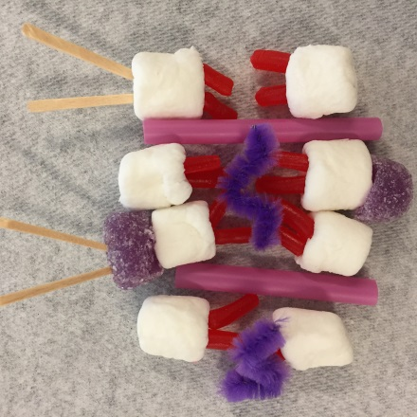
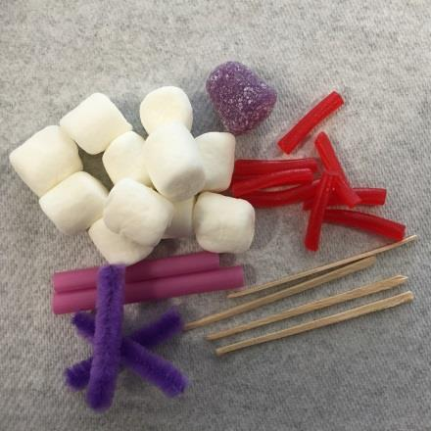
You will be creating a model of the cell membrane, including the phospholipid bilayer, channel (integral) proteins, carbohydrate signaling chains, and cholesterol.
You will need the following:
10 Marshmallows
20 Small pieces of Twizzler Pull n Peel
2 straw sections
2 toothpicks
2-3 1/2inch sections of pipe cleaner
1 paper towel

To create your cell membrane Model:
- Poke two pieces of Twizzler into each marshmallow, then lay your marshmallows down on your paper towel in two rows with the twizzlers pointing inwards- These will be the main part of your lipid bilayer and will form the barrier to the outside world.
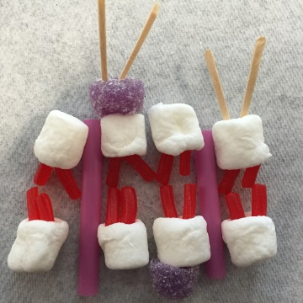
- Lay your straws between two marshmallows (make sure the straws aren’t right next to each other). These will allow larger molecules in and out of your cell.
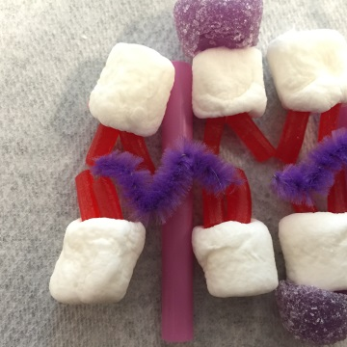
- Take 2 toothpicks and break them in half. Take the two toothpick halves and poke them into the top of a marshmallow at the top of your bilayer. These are used to signal and identify your cell.
- Cut 2-3 1/2inch sections of pipe cleaner. Gently bend the pipe cleaner into a wiggly w-shape. Place the bent pipe cleaner between your bilayer so they lay between/on-top of the twizzler tails.
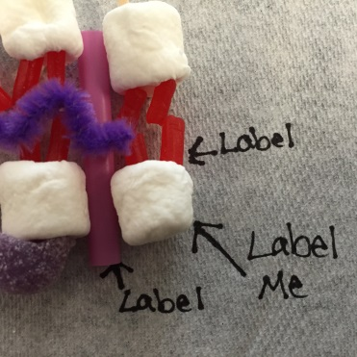
- On your paper towel, label all the parts of your cell membrane. Be sure to draw arrows pointing to the part you are labeling. Use your worksheet as a guide. Also label which side of your membrane is the exterior (outside) of the cell, and which side is the protoplasmic (inside) of the cell.

Your model should be complete, raise your hand and ask your teacher to come check your model. Once the teacher has approved complete questions on the back:
Teacher Signature:
____________ (40 pts)
Cell Membrane Model Questions
- For each model part listed tell what part of the cell membrane it represents, what the function of that part is and the macromolecule(s) (biomolecule) that it is made of :
Model Part | Membrane Unit | Function or Trait | Macromolecule(s)/Biomolecules
Marshmallow
Twizzler “Tails”
Marshmallow and Twizzler Together
Straws
Toothpicks
Pipe Cleaner
- Which part of your phospholipid is hydrophilic? Which part of your phospholipid is hydrophobic? Draw and label

- Explain how the hydrophilic and hydrophobic parts arrange themselves? Why is arrangement important for cells? (Hint: Think about where water is in relation to the membrane)

- What is the function of the cell membrane?

- Because cell membranes are fluid (the parts are constantly moving), small spaces open and close between the lipids. This makes the membrane selectively permeable, meaning that only some molecules are able to move through the membrane. Unfortunately, some of the molecules that a cell needs are too large to simply move through the membrane. Which membrane part is used to help these larger molecules in and out of the cell?

