Name: ____________________________ Period: _____ Date: _________

Osmosis Worksheet
Below are animal cells placed in beakers of various concentrations.
1. Draw an arrow to show which way the water would move by osmosis
2. Fill in any missing percentages (water or solute)
3. Identify the type of solution (isotonic, hypertonic, or hypotonic)

1._____________________ 2.________________________ 3.____________________

4._____________________ 5.__________________________ 6.____________________
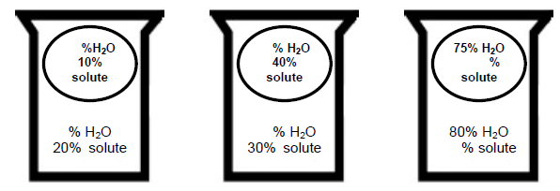

7._____________________ 8__________________________ 9.____________________

