Name_________________________________________ Date:______________ Period:_______

Protein Synthesis Test Review

- Protein synthesis is the process of making a _________________ by using instructions from DNA. A section of DNA is called a __________ and each codes for a particular protein.
- RNA acts as an intermediate link between DNA in the nucleus and protein synthesis in the cytoplasm. Like DNA, RNA (ribonucleic acid ) is a _________ of nucleotides. RNA differs from DNA in three significant ways. Make a T chart comparing DNA and RNA

- Indicate in your T chart the location of DNA and RNA

- List and briefly describe the function of the 3 types of RNA.

- During transcription, a section of DNA (gene) unwinds and is copied into what type of RNA? ______________________ Where in the cell does transcription occur? ________________ What enzyme is involved in this process?

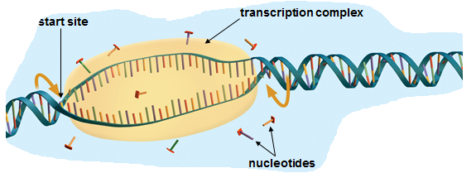

- Refer to diagram below and label the DNA molecule and the mRNA.

- In your own words describe what is happening in this step of Transcription. Use the following words in your description: RNA nucleotides, complementary base pairs (A,U,G,C), DNA template,RNA polymerase

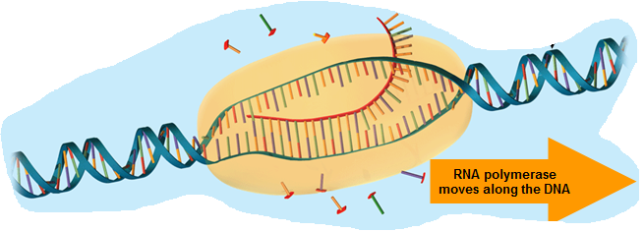

______________________________________________________________________________________________________________________________________________________________________________________________________________________________________________________________________________________________________________________________________________________________________________________________________

- Suppose you had the following DNA segment being transcribed. What would the mRNA look like according to base pairs?
(DNA) ATT - ACC- GGT- GAT- AAA
(mRNA) ____ ____ ___ ____ ____

- During translation, the information from the mRNA is used to make a __________________
The mRNA moves from the ___________ to the cytoplasm where it will bind to a ___________ (organelle).

- What is a codon? Indicate on the diagram below a DNA triplet.
Indicate on the diagram below a codon.
How many triplets are shown? ____
How many codons are shown? ____
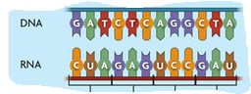
How many amino acids will form from the
section of RNA? _____

- During translation, the mRNA attaches to the ribosome at the _________codon. Each codon will code for ______ amino acid. Next, the anticodon of a tRNA molecule will attach to the ______ of the mRNA. The tRNA carries an ________ ______ that is specific to the codon on the mRNA strand.

- Refer to diagram below and label the following: tRNA, amino acid, codon, anticodon, ribosome
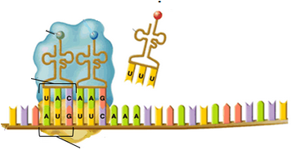

- tRNA molecules continue to attach to the mRNA and bring amino acids which are bonded together by _________________ bonds . Explain what will happen when a stop codon is reached?

Use a codon chart from your notes and answer questions 13-15.

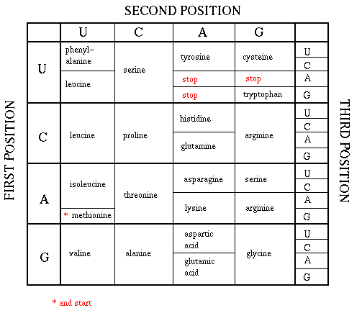
- What is the amino acid coded for by the codon GGU? __________________

- What is the amino acid coded for by the codon CCU? __________________

- What codon will STOP a polypeptide chain? ______

- What is cell differentiation?
17. Give an example of a type of cell that has not become specialized yet.

18. Explain what happens once a cell differentiates.

19. In two or three sentences, explain “Gene Expression”

20. In two or three sentences, explain the role of DNA and the role of RNA in gene expression.

21. List 4 environmental factors that can influence what genes are expressed.

22. A gene mutation is a ___________ in the DNA sequence.

a. Point Mutations-

b. Frameshift Mutations-

23. Which type of mutation will usually only affect one amino acid and are caught and corrected by
DNA polymerase? __________________________________

24. Which type of mutation involves every amino acid after the mutation?

25. Which type of mutation is shown below: _________________________
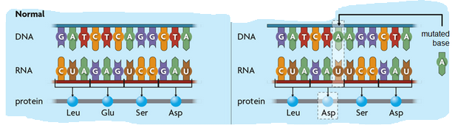

26. Which type of mutation is shown below: _________________________
