Unit 1 Review: Biomolecules
- List the levels of organization- from smallest to largest:
- Which biomolecule provides more energy on a gram per gram basis, a carbohydrate or a lipid?

- Define the following terms:
  - Biomolecules
  - Monomer
  - Polymer
  - Dehydration synthesis
  - Hydrolysis
- List the elements found in each biomolecule:
  - Carbohydrates –
  - Lipids -
  - Proteins –
  - Nucleic Acids –
- Fill out the following Macromolecule chart with the information needed. Indicate what type of biomolecule is shown/described and indicate the monomer or structural unit:
What type of  biomolecule? 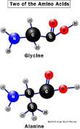  Monomer? | What type of biomolecule?  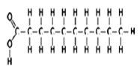  Structural unit? | What type of biomolecule?  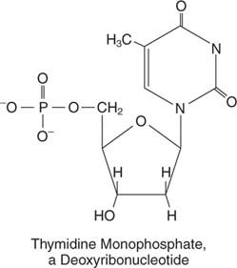  Monomer? | What type of biomolecule?  Monomer?
What is the Function of this biomolecule? | What is the Function of this biomolecule? | What is the Function of this biomolecule? | What is the Function of this biomolecule?

- What is another term for a “biological catalyst”?

- What type of macromolecule is an enzyme?

- What do enzymes do? How do they do it?

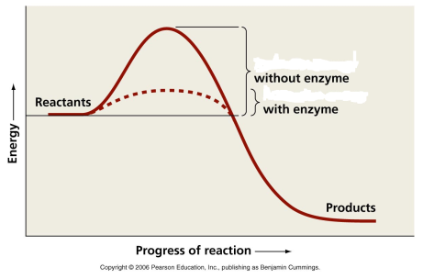

- Can enzymes act on any substrate, or are they specific?

- Look at the diagram to the right. What does the addition of the enzyme do to the activation energy?

- Underline which of the following could change the rate of a reaction, and highlight which could cause an enzyme to denature:

  - Adding more substrate
  - Diluting the enzyme mixture (less enzymes)
  - Lowering the temperature
  - Altering the pH of the solution
  - Raising the temperature to above boiling

- Label on the diagram below: substrate, products, enzyme, active site
