Unit 2: Cell Structures and Processes Review
Need Extra help with reviewing? Go here for more resources: tinyurl.com/sphsbiounit2review

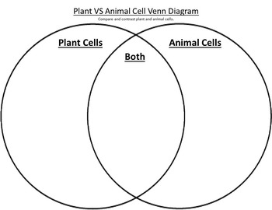
1.Compare and contrast the types of cells
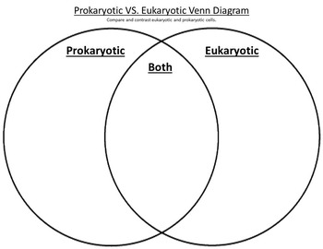

2. What two organelles are thought to be a result of endosymbiosis?

3. Define Endosymbiosis

4. What features are shared by all types of cells?

Letter | Name | Function | What type of biomolecule(s)
A
B
C
D
E
F
G
5. Label the parts of the cell membrane
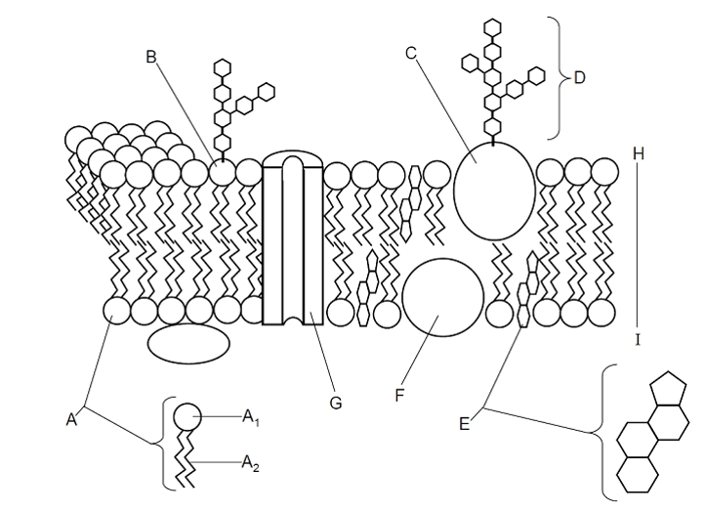

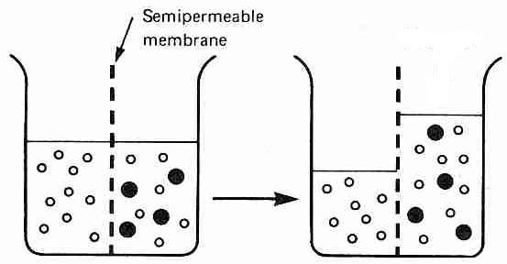
Explain what has happened in the diagram to the left.

- Why did the large dark molecules NOT move to the left?

- How is the semi-permeable membrane like a cell membrane?

- If the dark molecule is starch, where is the starch concentration greatest (left or right)?

- If the white molecule is water, where is the water concentration greatest in the first picture?

- In osmosis, water moves from an area of concentration of stuff to an area of concentration of
. stuff(higher/lower)

- If the dark molecules(in the diagram) could move, in what direction would they move? Why?

- In diffusion, molecules move from an area of to an area of concentration. (higher/lower)

- Which way water will move in each of the following situations:
  - Salt inside the cell 65% and outside the cell 40%.
  - Sugar inside the cell 27% and outside 80%.

- What is homeostasis?

- How does the cell membrane help maintain homeostasis?

21. Comparison of active and passive transport
 | PASSIVE TRANPORT | ACTIVE TRANSPORT
Requires energy?
Low to high concentration or
high to low concentration?
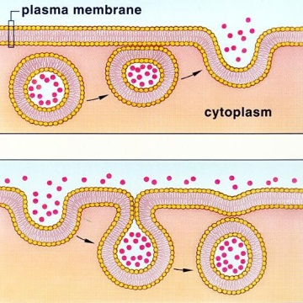
Examples
A
B

- Label the diagram to the left (A and B) as Endocytosis and Exocytosis

- Give an example and a purpose for both A and B
B

- Label the processes as Active or Passive. What does this mean for the cell?

