Unit 6 and 7- Animal and Plant Systems Review
1. For each of the following plant parts explain how they work together to transport materials around the plant:
a. Roots -
b. Stems -
c. Leaves -
d. Xylem -
e. Phloem -
f. Stomata-
2. What is transpiration? Why is it important for the plant?

2. Define and give an example for each of the four tropisms.
A. | B.
C. | D.

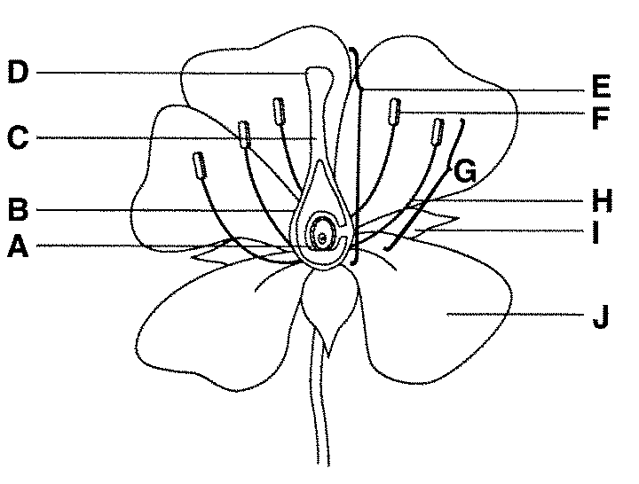
3. Label the reproductive parts of the flower below. Color the Male parts blue and the Female parts red. For each part explain the function.
A.
B.
C.
D.
E.
F.
H.
I.
J

4. How are microbes related to the nitrogen cycle? Are they beneficial or harmful?
5. Label each of the systems below- give a 2 word purpose for each. 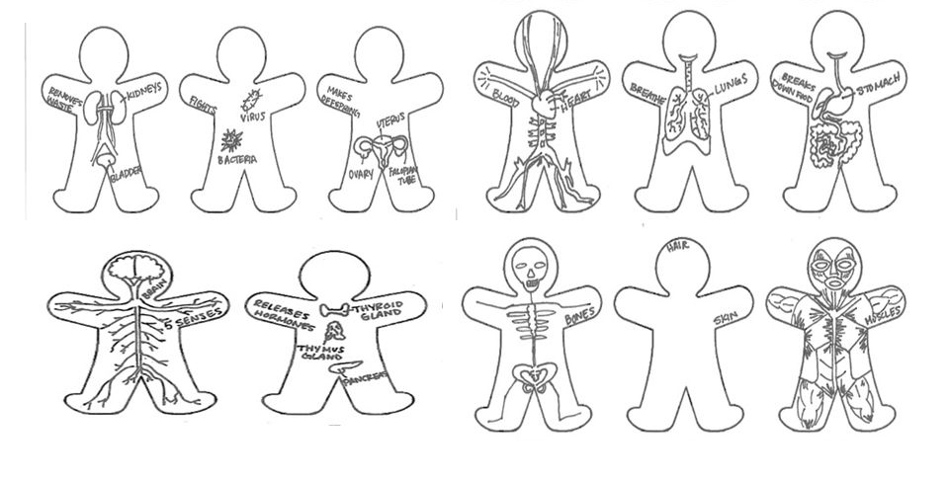
6. Explain how positive and negative feedback loops work- give an example of each.

7. For each of the following- name the systems that are working together.
a. Contributes to maintaining homeostasis by removing cellular waste AND maintaining water and salt balance. (2)
b. Langerhans cells are present in the epidermis of the skin and provide the first line of defense against infections by initiating an inflammatory response when pathogens enter. (2)
c. The pituitary gland in the base of the skull releases hormones that control blood pressure. (2)
d. The pineal gland releases melatonin, a hormone that helps the brain recognize when it is time to go to sleep. (2)
e. Kidneys filtering waste from the blood (2)
f. White blood cells are components of the blood that protect the body from infectious agents. They identify, destroy, and remove pathogens, damaged cells, cancerous cells, and foreign matter from the body. (2)
g. Nutrients in the mother’s blood diffuse through the placenta and are carried to the developing embryo via blood vessels in the umbilical cord. (3)+
h. The bladder contracts to push urine out of the body via the urethra. (2)

